AIR-FARE BOOKING SYSTEM

DOCUMENTATION

Submission:
To: Lecturer Miss Ayesha Inayat
For: Object Oriented Programming – Semester Project for the Session Fall 2025 (BSSE-3T)
Dated: 10th January, 2026
Developed by team of 5 members:
Syed Mubazir Haider, Abdul Moez, Aleeza Bibi, Moiz Rizwan, Urwa Iqbal

Introduction:
Air transportation has become one of the most important modes of travel in the modern world. With the increase in population, globalization, tourism, and business travel, the demand for efficient airline services has grown rapidly. Traditional airline ticket booking methods relied heavily on manual processes, travel agents, physical counters, and paperwork. These methods were time-consuming, error-prone, and inconvenient for passengers.
The Air-Fare Booking System is designed to overcome these limitations by providing a computerized and automated solution. This system allows passengers to search flights, check seat availability, book tickets, and manage reservations through a digital platform. Airlines can also manage flights, schedules, and passenger data efficiently.
This project focuses on building a simple yet effective Air-Fare Booking System using C++ programming, MySQL database and Python for connecting both, following Object-Oriented Programming (OOP) principles. The system addresses the limitations of traditional manual booking processes, such as human errors, inefficient data management, and slow operations. ABS allow users to register passengers, schedule flights, manage airline and airplane information, book tickets, generate tickets in PDF format, and track flights in real-time.
By combining object-oriented programming principles with modular design, ABS ensure maintainability, scalability, and error handling throughout its operations. This documentation provides a detailed overview of the system architecture, module descriptions, implementation details, user interface, testing, and future enhancements. It serves as both a guide and a reference for users, developers, and evaluators.

Background:
Airline management is a complex process involving multiple tasks such as scheduling flights, managing aircraft, booking tickets, and keeping track of passengers. Traditionally, many airlines relied on manual booking systems, phone-based reservations, or disconnected software solutions. These approaches often lead to inefficiencies, errors, and delays in service delivery.
With the growing demand for efficient airline management systems, there is a need for an integrated software solution that can handle multiple operations simultaneously while providing a user-friendly interface and accurate data management.

Motivation:
The motivation behind developing the ABS project includes:
- Automation of manual processes: Reducing human errors in booking and flight management.
- Centralized data management: Storing airline, flight, passenger, and ticket information efficiently.
- Improved user experience: Simple console-based interface for administrators and users.
- Scalability: Modular design allows adding new features like seat selection, flight reports, or payment integration in the future.
By implementing this system, the team aimed to demonstrate practical application of object-oriented programming in a real-world scenario while creating a functional software that can be extended for larger airline operations.
Scope:
The scope of ABS includes the following functionalities:
- Airline Management: Add, view, and manage airline companies including country of origin and airline code.
- Airplane Management: Manage aircraft details such as model, seating arrangement, and assignment to airlines.
- Flight Scheduling: Schedule flights with source, destination, date, and take-off time.
- Passenger Management: Register passengers, maintain contact details, and track last flight.
- Ticket Booking: Reserve seats, assign ticket numbers, calculate price, generate PDF tickets, and track booking status.
- Admin Interface: Admin login with privilege access to manage airlines, airplanes, and flights.
- System Environment: The system is console-based, designed for desktop usage, and integrates Python scripts to handle data persistence in a lightweight database structure.

System Objectives:
The Airfare Booking System is designed with the following objectives:
Functional Objectives
- Register new airlines and airplanes.
- Schedule and manage flights.
- Register passengers and update last flight data.
- Book tickets for passengers on scheduled flights.
- Generate tickets in PDF format for passengers.
- Search flights by location or date
- Display current flights and historical flight data.

Non-Functional Objectives
- Usability: Simple and intuitive console-based interface.
- Reliability: Accurate data management with error handling.
- Scalability: Modular design allows future upgrades.
- Maintainability: Object-oriented design with reusable classes and functions.
- Performance: Efficient execution using C++ and Python scripts for database operations.

System Requirements:
For the purpose of best efficient system use the following pre-requisites are important
Hardware Requirements
- Minimum 4 GB RAM
- Processor: Intel i3 or equivalent
- Hard Disk: 500 MB free space
- Operating System: Windows 10 or later
Software Requirements
- C++ Compiler (Dev C++)
- Python 3.x for database scripts
- Windows API (for console enhancements and icons)
- Optional: PDF library for ticket generation
Development Tools
- C++: For core logic and object-oriented design.
- Python: For database handling (CRUD operations).
- SQL: For database storing data.
- Windows API: For console customization and appearance enhancements.
- Dev C++: For editing scripts.

System Analysis:
Current System Limitations
Before the ABS, airlines often relied on manual or partial digital systems, which had the following issues:
- Manual Booking Errors: Human mistakes during ticket entry or flight scheduling.
- Inefficient Passenger Tracking: No centralized record of passengers or flight history.
- Time-Consuming Operations: Booking, cancellation, and data retrieval were slow.
- Data Redundancy: Repetition of passenger or flight information across multiple files.
- Limited Access Control: No role-based admin privileges.
Proposed System Advantages
- Automation: Flights, passengers, and tickets are managed through a unified system.
- Data Accuracy: Real-time updates reduce errors.
- User-Friendly Interface: Console menus with clear options and validations.
- Modular Design: Each entity (Passenger, Flight, Airline, Ticket) is independent and reusable.
- Admin Privileges: Secure access to critical modules with login authentication.
System Design and Architecture:
The Airfare Booking System (ABS) is designed using a modular object-oriented architecture, allowing flexibility, maintainability, and scalability. The system is divided into multiple independent modules, each responsible for specific functionalities:
Modules Overview
- Airline Module – Manages airline companies and their details.
- Airplane Module – Handles aircraft details and assignment to airlines.
- Flight Module – Schedules and manages flights with dates, times, and capacity.
- Passenger Module – Registers and maintains passenger information.
- Ticket Module – Books tickets, generates PDFs, and tracks booking status.
- Admin Module – Handles authentication and overall management of the system.
Flowchart of ABS
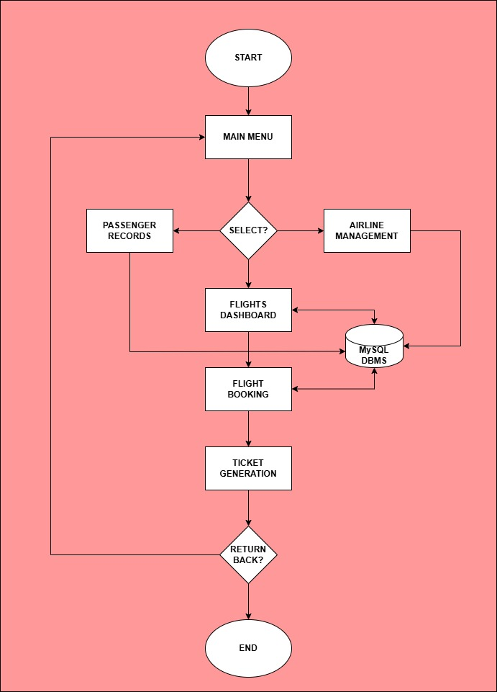
Classes and Functions:
Airline
Attributes: id, name, country, code
Methods: addAirline(), viewAirline(), updateAirline()

Airplane (inherits from Airline)
Attributes: model, seatCapacity, airlineId
Methods: addAirplane(), viewAirplane(), updateAirplane()

Flight
Attributes: flightId, airplaneId, source, destination, date, time
Methods: scheduleFlight(), viewFlight(), updateFlight()

Passenger
Attributes: passengerId, name, contact, lastFlightId
Methods: registerPassenger(), viewPassenger(), updatePassenger()

Ticket
Attributes: ticketId, flightId, passengerId, seatCode, price, dateOfBooking, status
Methods: bookTicket(), cancelTicket(), generatePDFTicket()

Entity Relationships:
Airline → Airplane: One-to-Many (An airline can have multiple airplanes)

Airplane → Flight: One-to-Many (A plane can be assigned to multiple flights)

Flight → Ticket: One-to-Many (Multiple tickets per flight)

Passenger → Ticket: One-to-Many (Passenger can book multiple tickets)

Airline → Flight: One-to-Many (An airline can have multiple flights)

Airline → Flight: One-to-Many (An airline can have multiple flights)

Module Descriptions:
1.Airline Module
- Purpose: Maintain airline details for system operations.
- Inputs: Airline name, country, airline code.
- Outputs: List of airlines, searchable by name or code.
Operations:
- addAirline(): Adds new airline to database.
- viewAirline(): Displays all registered airlines.
- updateAirline(): Updates airline information.

2.Airplane Module
- Purpose: Manage aircraft data, including seat capacity and airline assignment.
- Inheritance: Inherits from Airline for airline association.
Operations:
- addAirplane()
- viewAirplane()
- updateAirplane()
Attributes:
- model: Aircraft model.
- seatCapacity: Total seats.
- airlineId: Links to Airline.

3.Flight Module
- Purpose: Schedule and manage flights.
- Key Attributes: source, destination, date, time, airplaneId.
Operations:
- scheduleFlight(): Adds flight to system.
- viewFlight(): Displays flight schedule.
- updateFlight(): Modify flight details.
Important Logic:
- Ensures no two flights use the same airplane at the same time.
- Checks seat availability before allowing ticket booking.

4. Passenger Module
- Purpose: Store passenger info and manage bookings.
- Attributes: passengerId, name, contact, lastFlightId.
Operations:
- registerPassenger()
- viewPassenger()
- updatePassenger()

5. Ticket Module
- Purpose: Book tickets and generate PDF confirmations.
- Attributes: ticketId, seatCode, price, status.
Operations:
- bookTicket(): Reserves seat and assigns ticket number.
- cancelTicket(): Cancels booking and updates availability.
- generatePDFTicket(): Produces ticket for passenger.
Important Logic:
- Ensures no double booking of seats.
- Calculates fare based on seat type and flight duration.

6. Admin Module
- Purpose: Control access to modules and maintain system integrity.
- Attributes: username, password.

Workflow:
- Admin inputs data for Airlines, Airplanes, and Flights → System validates and stores.

- Passengen Registers → Passenger Module Stores Information.

- Passenger books ticket → Ticket Module verifies flight availability → Updates Ticket Database → Generates Ticket PDF.

- Flight Module checks for plane availability.

- Ticket Module calculates fare based on seat class.

- Passenger Module updates last flight info after booking confirmation.

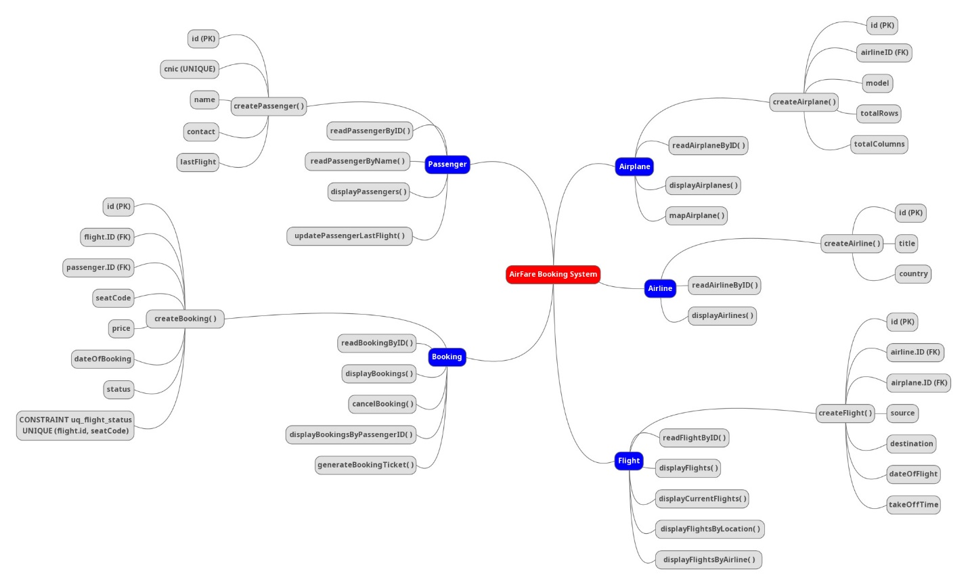

Use Case Diagram:

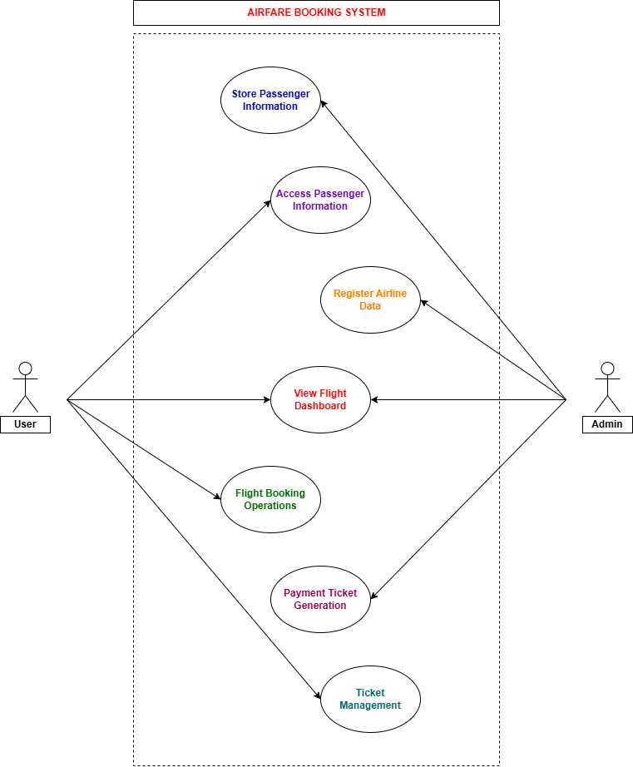

OOP Concepts:

Classes and Objects
Classes represent real-world entities such as Passenger, Flight, Ticket, Airline, and Airplane.

Encapsulation
Encapsulation is used to protect sensitive data.

Inheritance
Different user roles inherit properties from a base User class.

Polymorphism
Same functions behave differently for different objects.

Abstraction
Complex processes are hidden from users.

Composition and Association
Used to define relationships between objects.

Constructors and Destructors
Used for initialization and cleanup.

Application Interface:
Setup Page
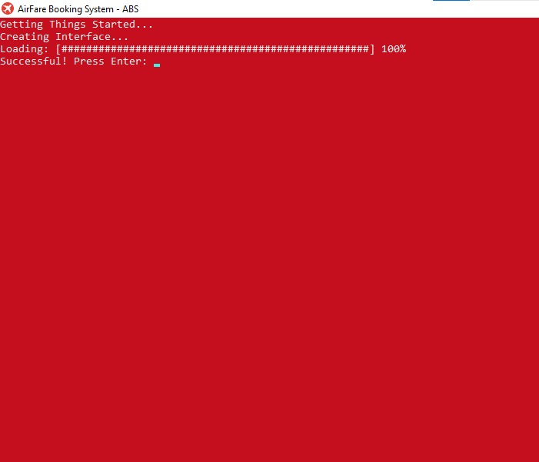

Main Page
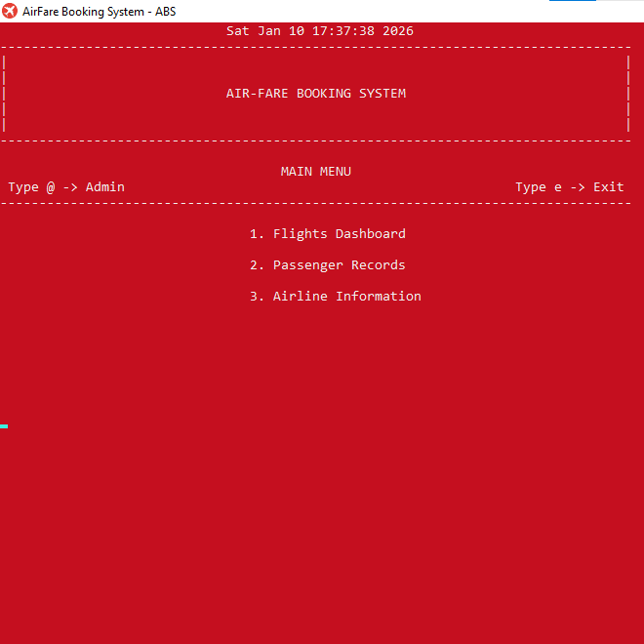
Flight Dashboard
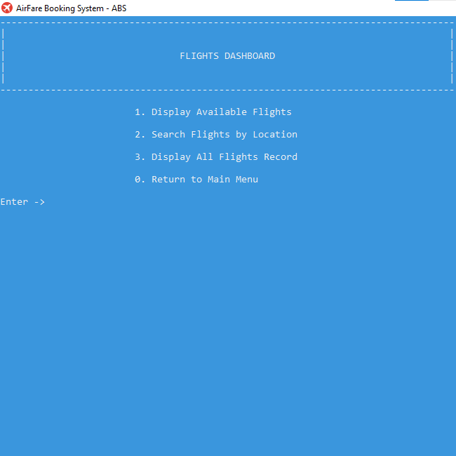

Passenger Records
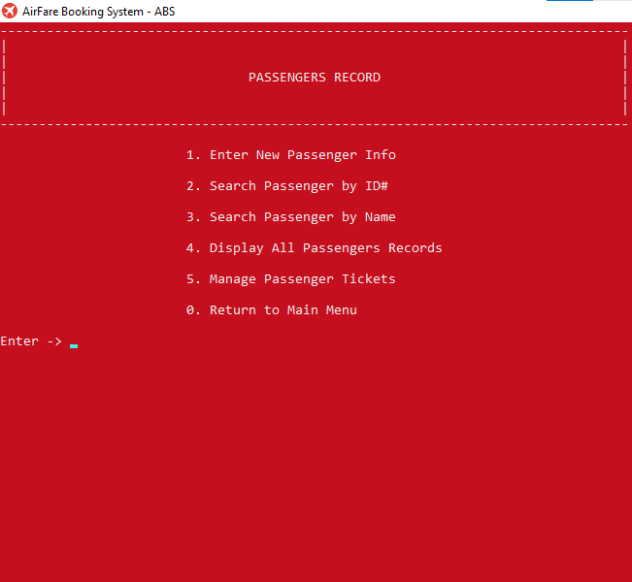
Login Page
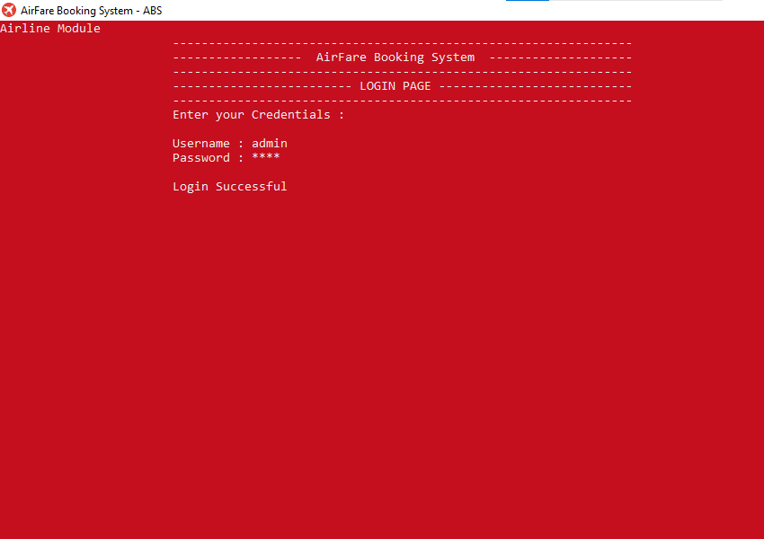

Airline Administration
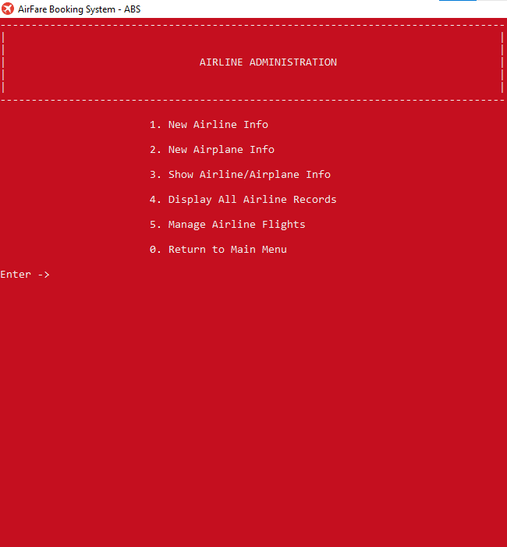
Add Flight Info
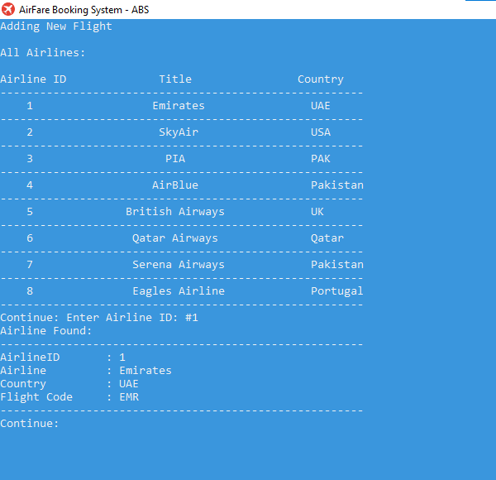

Add Flight Information
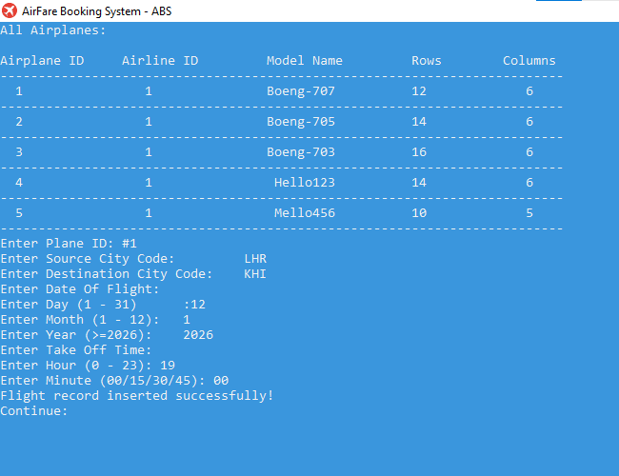

Flights Display
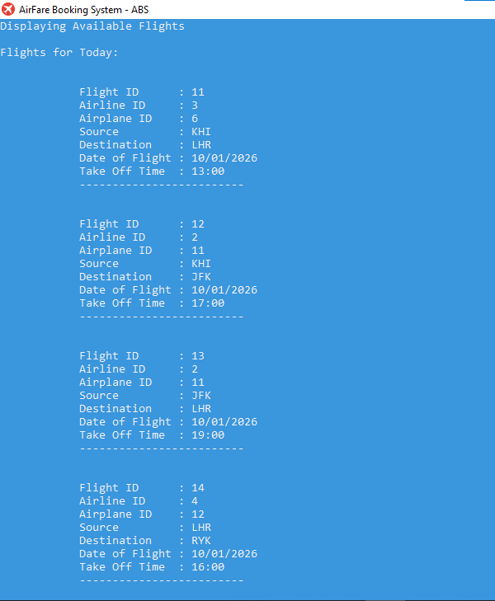

Booking Page
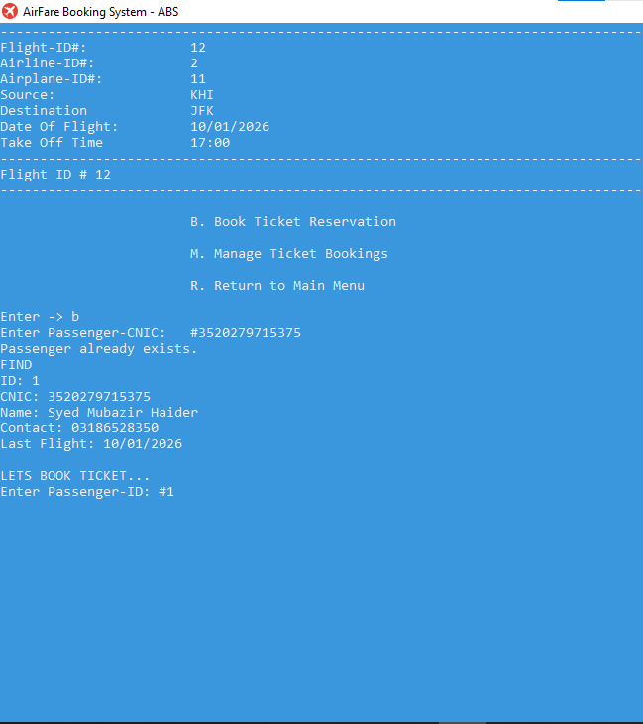

Seat Mapping Selection
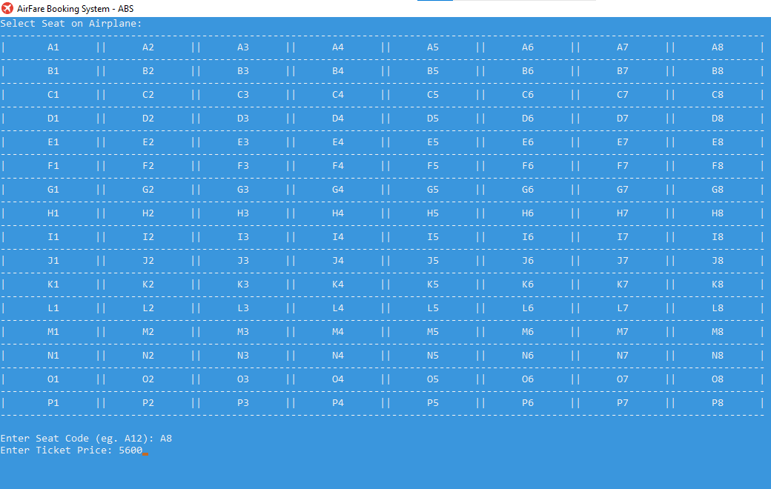

Ticket Generation
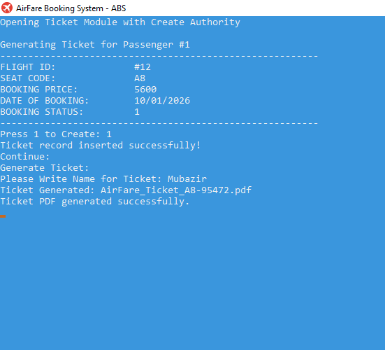
Ticket PDF Created
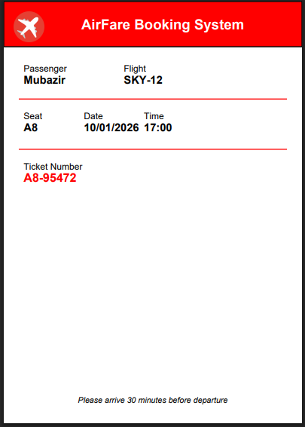

END OF DOCUMENTATION
PAGE 22 of 22

